**Docker Assignments**

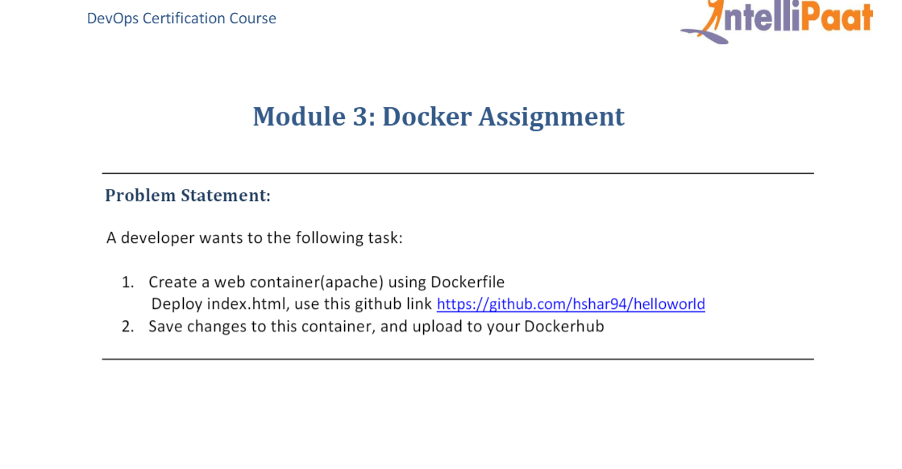

**Solution:**

root@71bb854cc6e0:/# history

1 apt-get install apche2

2 apt-get install apache2

3 apt-get update

4 apt-get install apache2

5 start service apache2

6 service apache2 start

7 exit

8 service apache start

9 service start apache

10 service start apache2

11 service apache2 status

12 service apache2 start

13 history

root@71bb854cc6e0:/# exit

exit

ubuntu@ip-172-31-80-241:~$ history

1 clear

2 sudo apt-get update

3 sudo apt-get install docker.io

4 systemctl status docker

5 ll

6 sudo docker ps -a

7 sudo docker images

8 sudo docker pull ubuntu

9 sudo docker images

10 sudo docker run -it -d --name c1 -p 80:80 ubuntu

11 sudo docker ps -a

12 sudo docker exec -it c1 bash

13 sudo docker commit c1 kashmir8/gauravimage

14 sudo docker images

15 sudo docker login

16 sudo docker push kashmir8/gauravimage

17 sudo docker run -itd --name c2 -p 81:80

18 sudo docker run -itd --name c2 -p 81:80 kashmir8/gauravimage

19 sudo docker ps

20 sudo docker exec -it c2 bash

**Screenshots:**

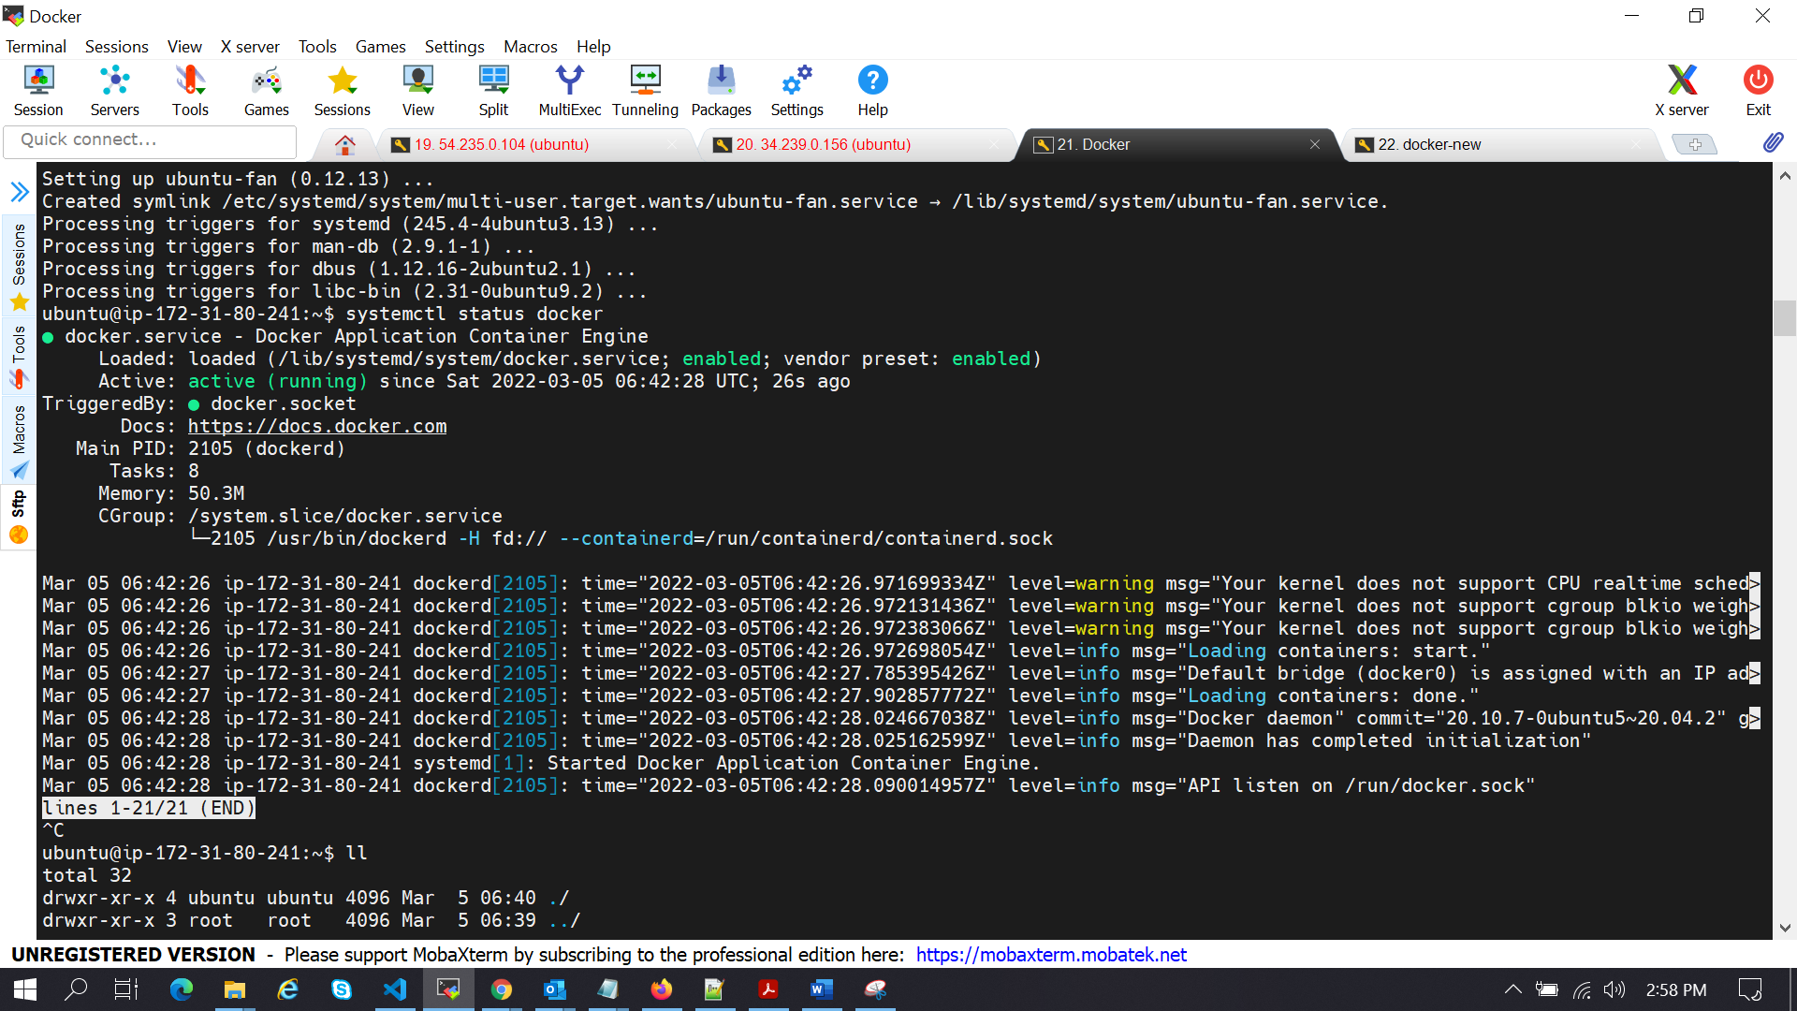

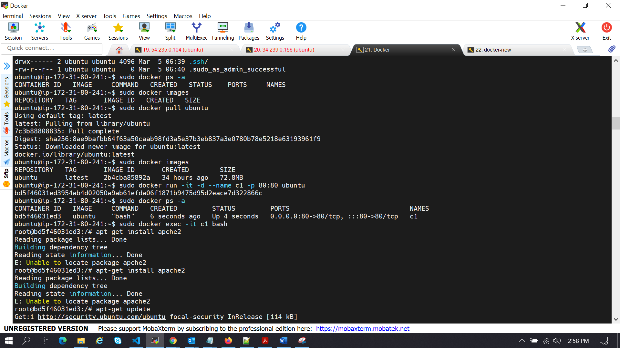

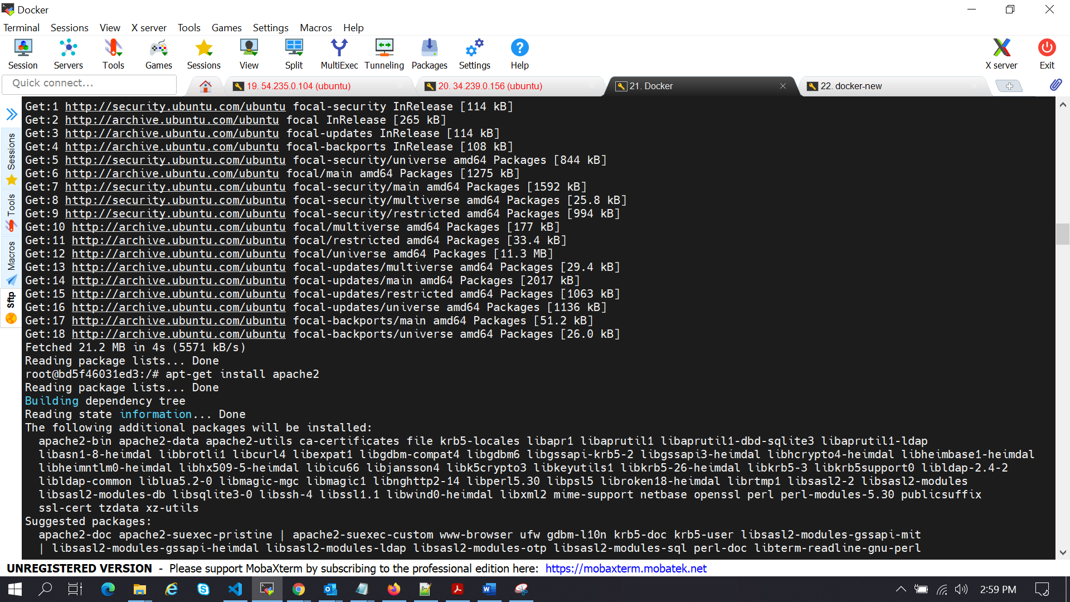

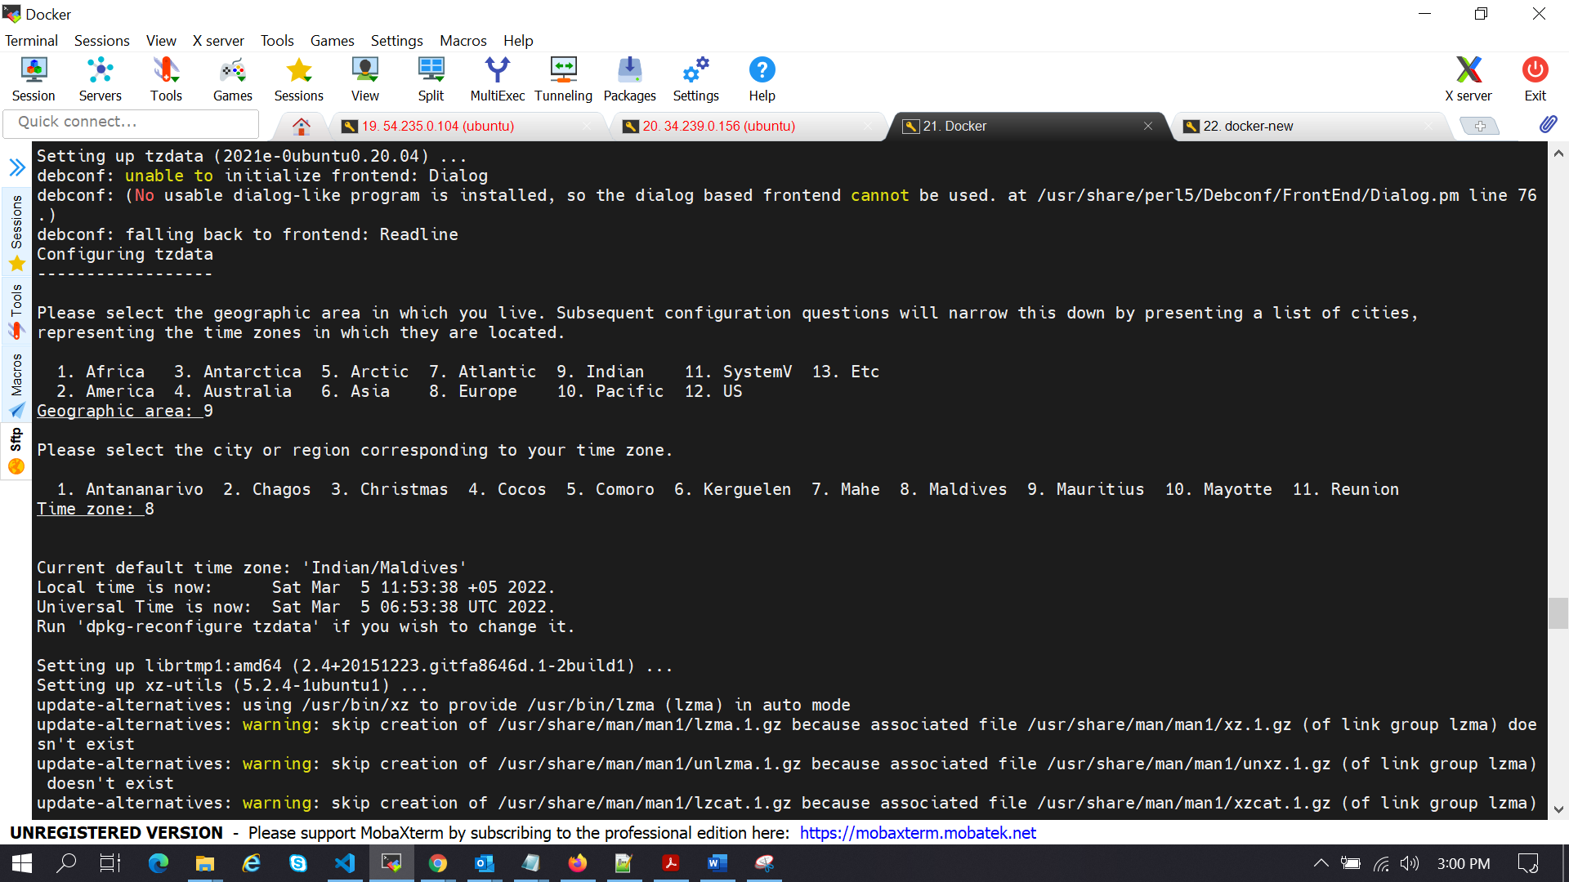

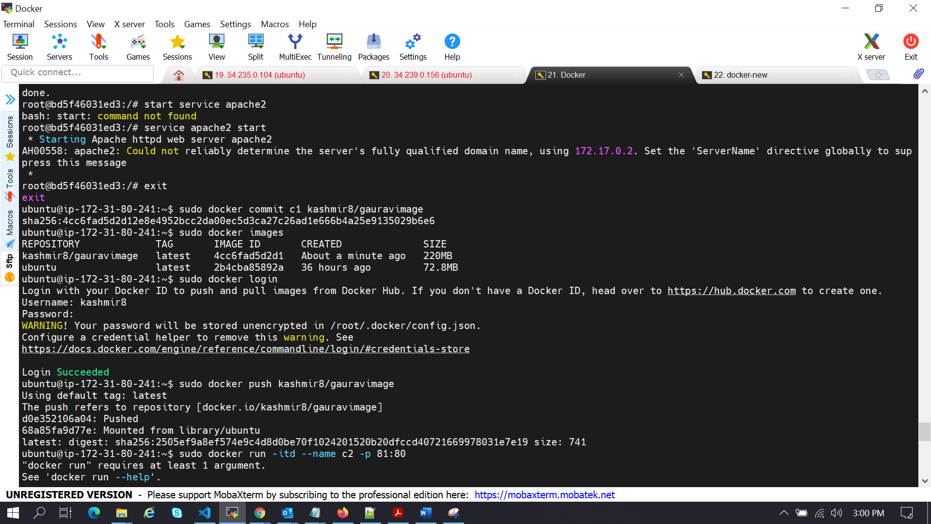

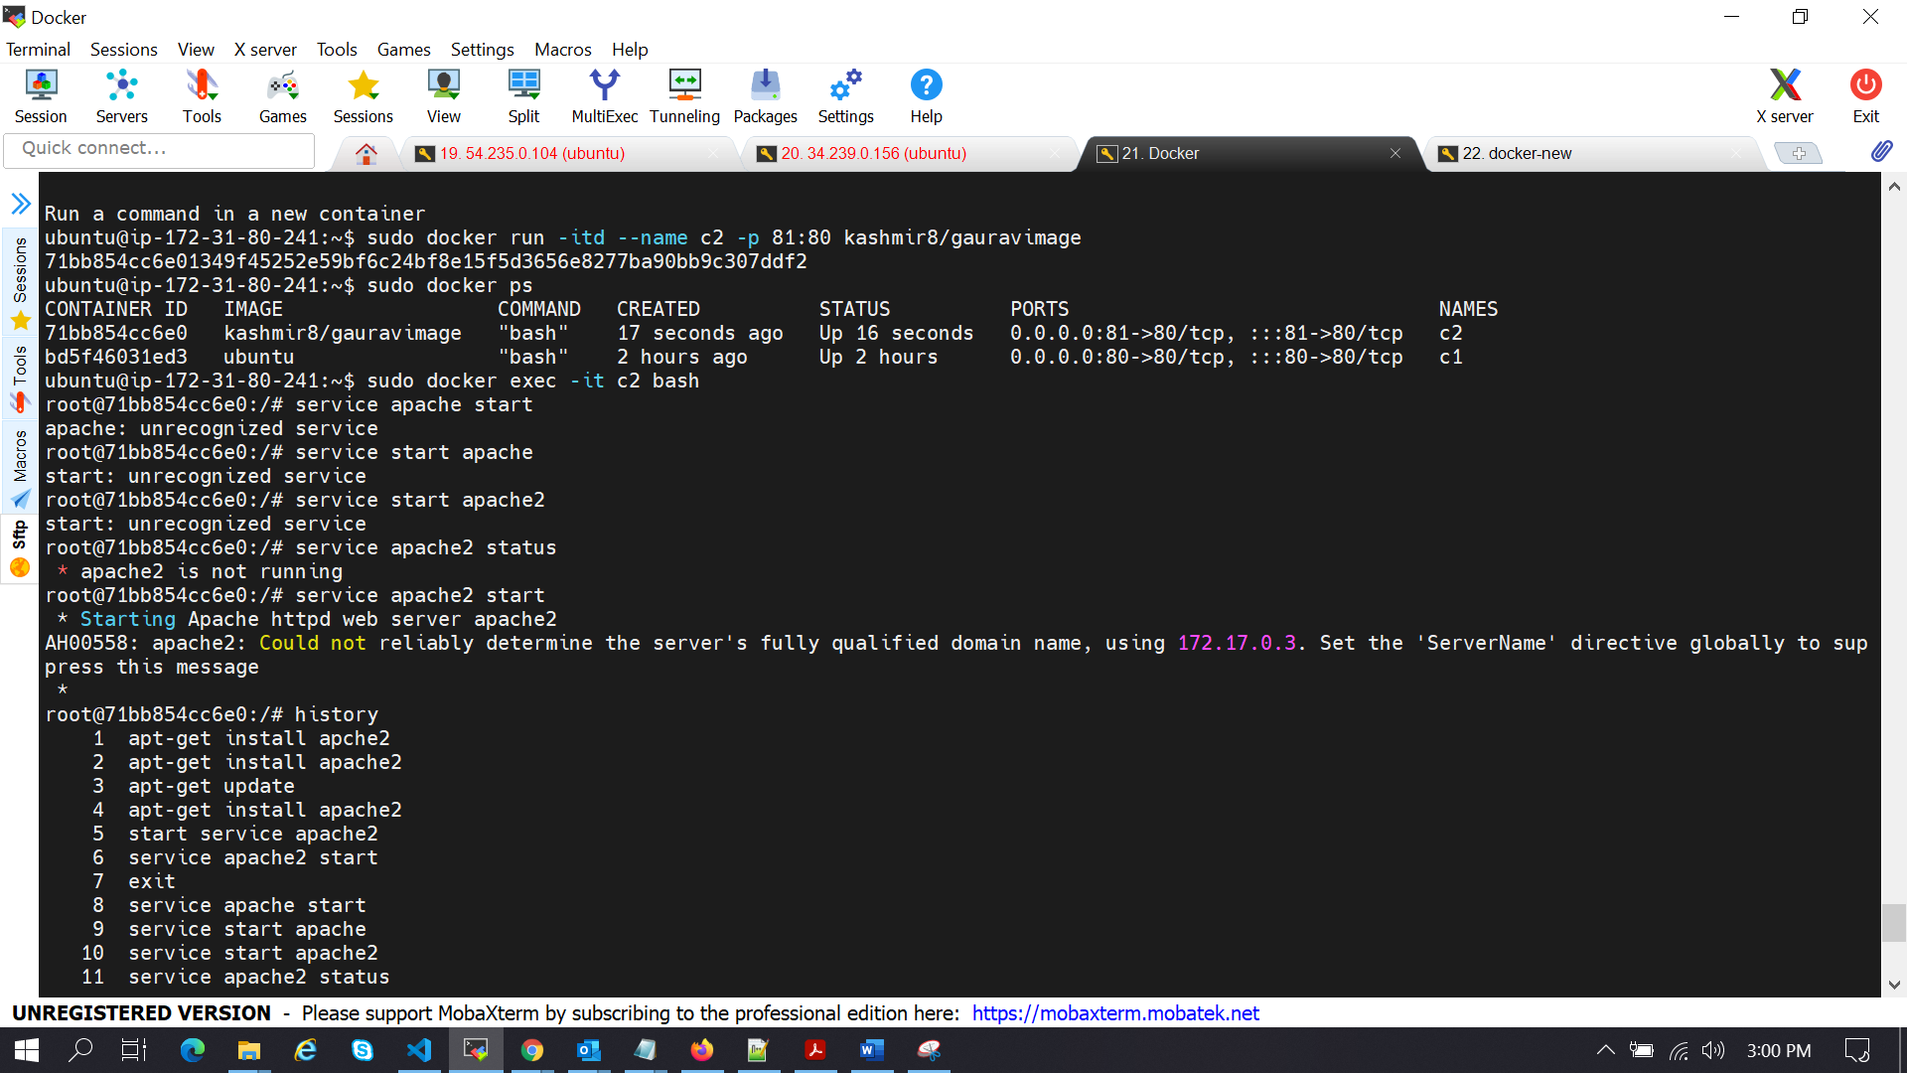

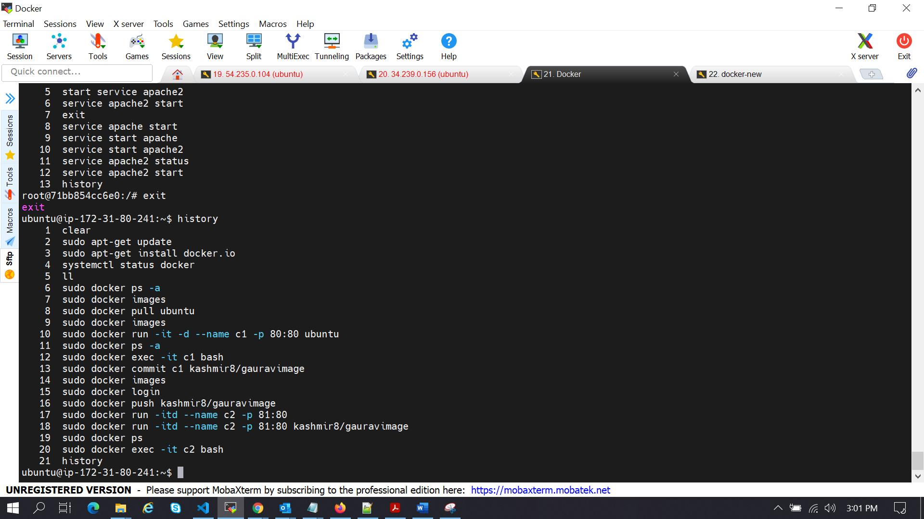

**Docker-New server**:

